[https://github.com/lukehoban/es6features----------------->ES6](https://github.com/lukehoban/es6features-----------------%3eES6) documentation

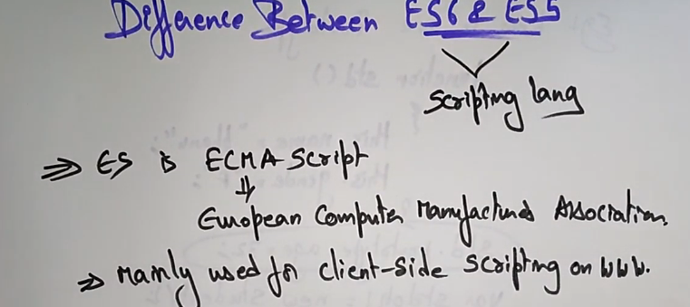

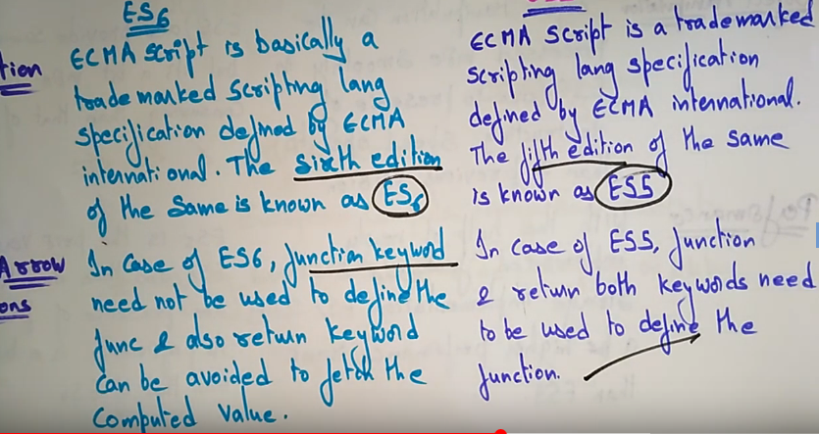

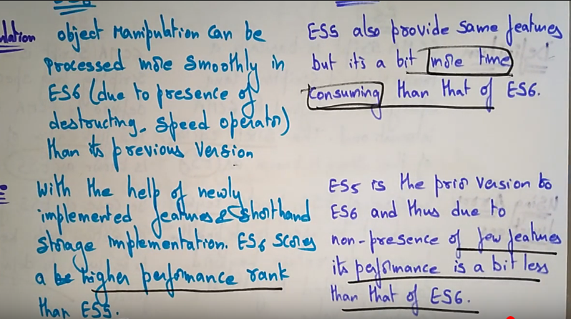

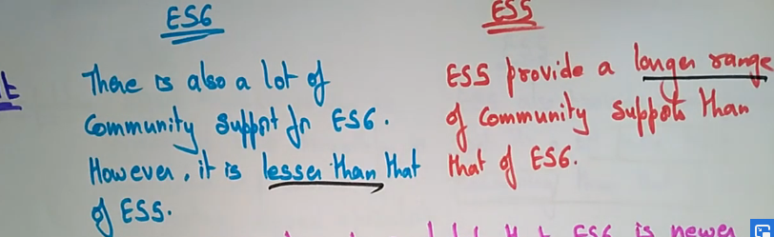

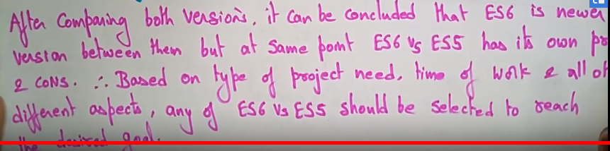

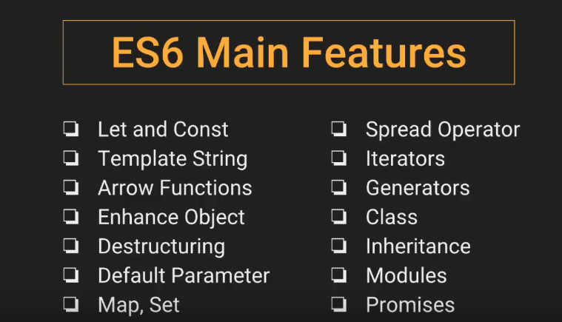

Java Script Promise

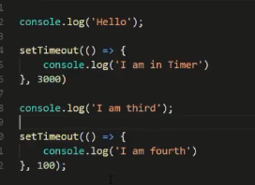 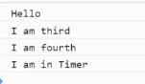

Asynchronous function, at first print hello then atlast print “I am in timer” print because it takes 3000ms this asynchronous function can be handle by promise

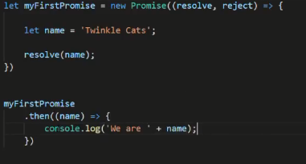 

Promise এর ভিতরে দুইটা আরগুমেন্ট পাঠাতে হই একটা resolve আর অন্নটি হচ্ছে reject. Promise টা True holay then resolve then promise false holay reject call korbay. Now this function true so ar resolve er parameter tai hobay .then er argument and then print the value.

Httprequest uses in ajax request , promise uses fetch api ‘

Asynchronous code variable e store kora jai na

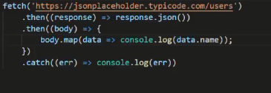

promise er maddome fetch api er maddome promise use koray name niye assay. Prothom .then response ekta promise then arro ekta promise use kora hoyesay .then body niye ekhon ektar vitoray onnow ekta promise thaktay parbay er jonnow ekadhik .catch use na koray ekta catch use korlai hobay

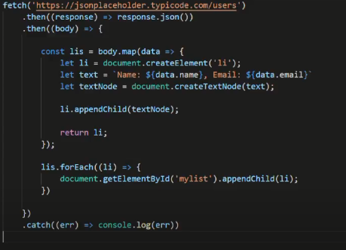

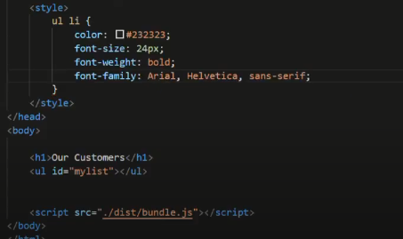



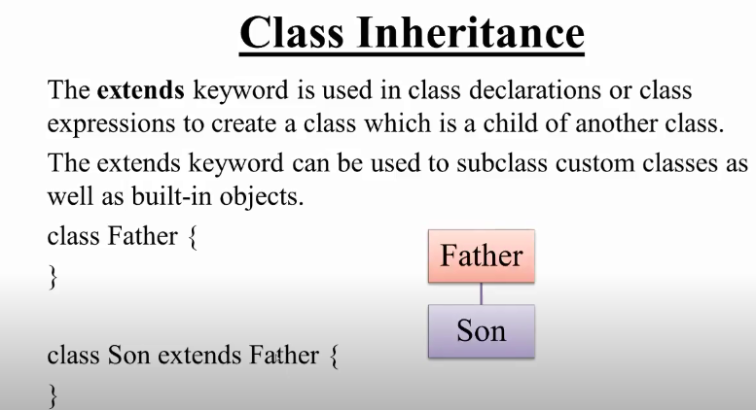 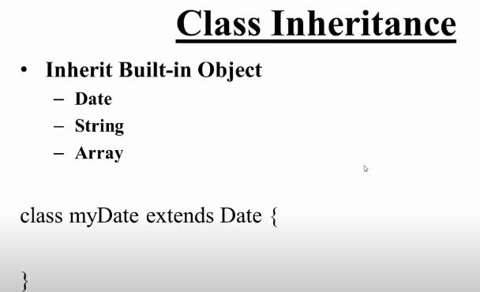

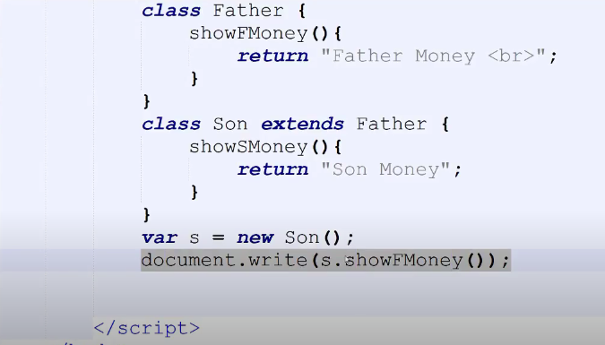 

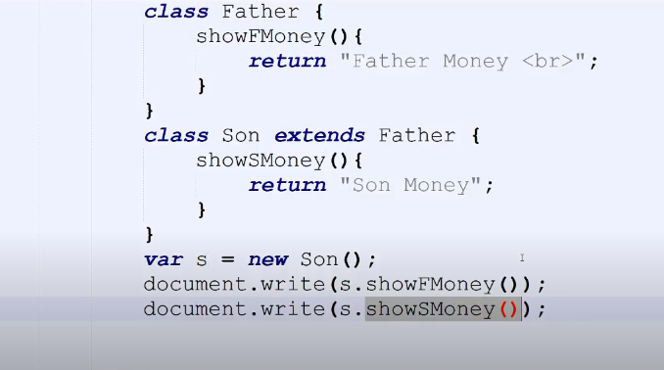 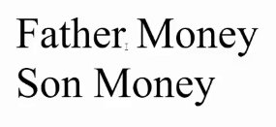

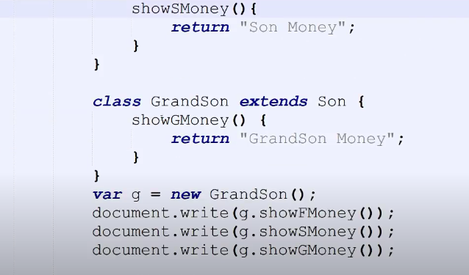 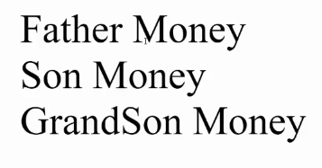

Export and Import

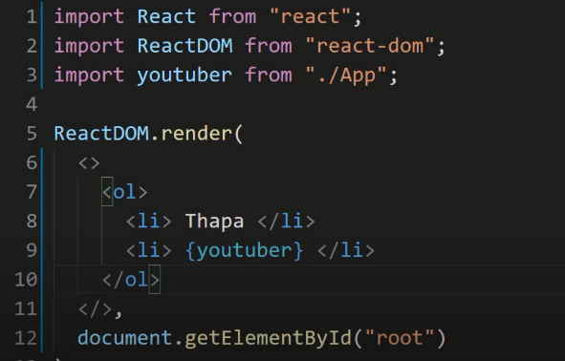 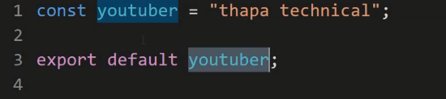 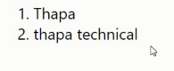

Like one file bolay dilo this file ta export er joggow then je kew oi file ta use kortay parbay kivabay use korbay import korar maddome . je file ta use korbay oi file ta uporay import likay markup koray dilai hobay.

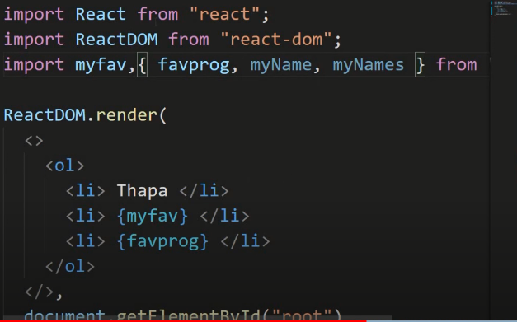 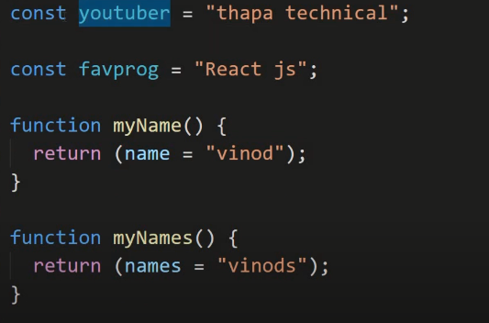

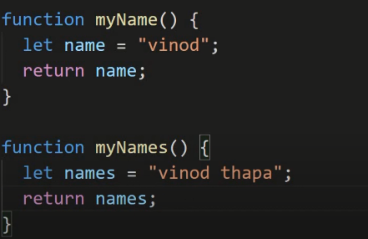 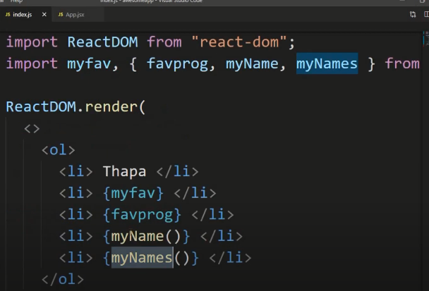 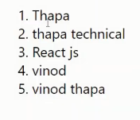

Synchronous and Asynchronous in JavaScript

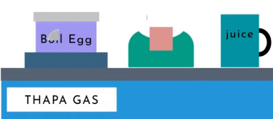

Like ekta kaj ses hoyer por arekta kaj hoitay hobay orthat serial break kora jabay na jemon prothomay pani fotaitay hobay then egg boil kortay hobay then toast prepare kortay hobay then juice make kortay hobay eivabay serial ei kaj kortay hobay are tai holo synchronous function. Orthat kaj sesh na holay onnow kaj ei jowa jabay na.

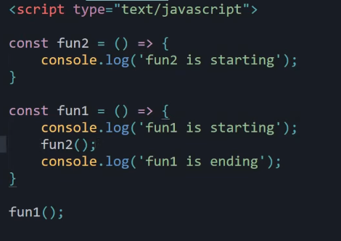 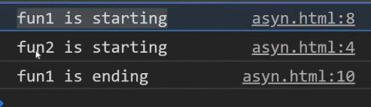

Asynchronous function

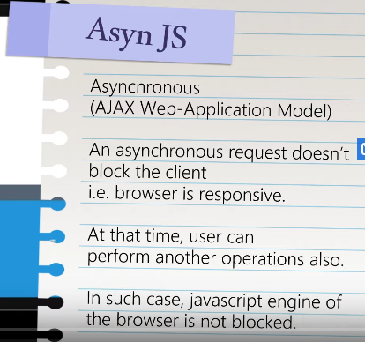

Asynchronous means multiple kaj eksathay kora jai ekta kaj er jonnow wait kora lagbay na at a time onek gula kaj eksathay kora jabay. Like eksathay egg boil kora jabay er sathay toast and juice prepare kora jabay etai hoschay asynchronous function.

Synchronous is dependent and Asynchronous is independent.

Anonymous function means je function er nam thakay na 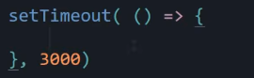

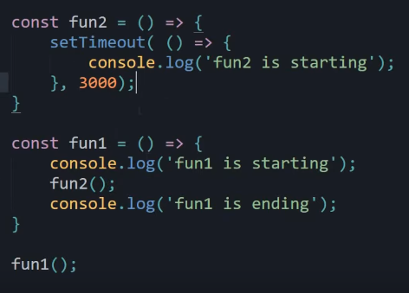 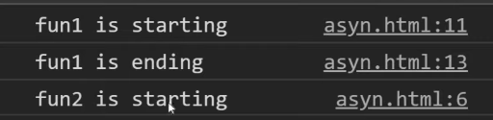

Like at first fun1 output dekhabay then pabay fun2 compiler fun2 tay giye dekbay timeout deya assay then fun1 er ending print korbay. Then 3 sec por fun2 print korbay. Orthat kew karo upor depend koray na.

JavaScript DOM

Javascript like ekta tree er moto kaj koray thakay reallife example ditay holay like ekta fruit partay hobay taolay atfirst tree tay utthay hobay then dall e jetay hobay then fruit ta chirtay hobay aretai holo DOM.

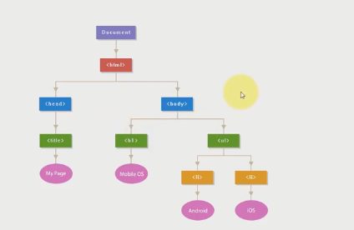

Like code e html holo parent of head and body then head ar body er child holo title, h1, ul eigular abar child assay taholay ei modeltakay ekta tree er sathay compare kora jai .DOM er moddew ei protech ta jinish royesay. Html er madhome code gulakay manipulate kora jai na . DOM er maddome code gulakay manipulate kora jai. Ekhanay document ta ekta element jeta window er ekta object. Browser er moddew window thakay. Window er ekta object hoschay document. Uporer protity element kay javascript diye manipulate kora jai. DOM hoschay ekta object oriented representation. DOM er maddome each element kay change kora jai.

Difference between var, let and const

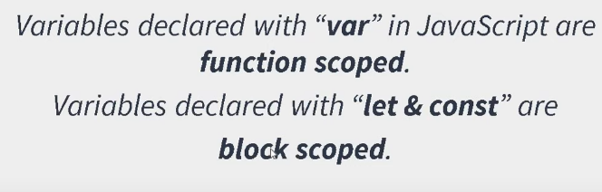

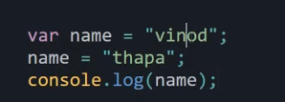 output-----thapa

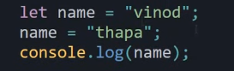 output-----thapa

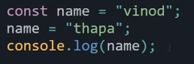 output-----Type Error. Because const use korlay er value change kora jai na tai error dekhai. Const er value khokhonoi change kora jabay na. variable fixed rakhtay chailay const usekotay hoi.

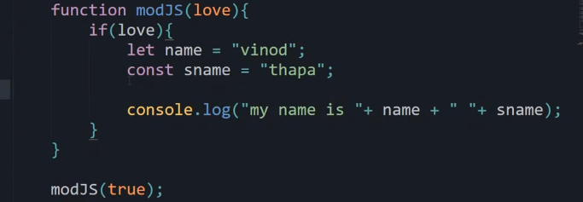 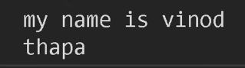

This part is function scoped this part is block scoped

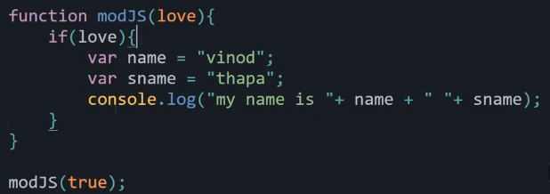 

There are no problem when we console.log in a block scoped. Sekhanay var, let, const ekoi behave korbay. Problem hobay jokhon block er bairay console.log kora hobay.

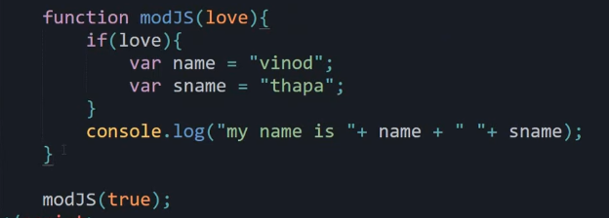 

Eikhanay var holo function scoped so console.log jekhanai use kori na kano result dibay

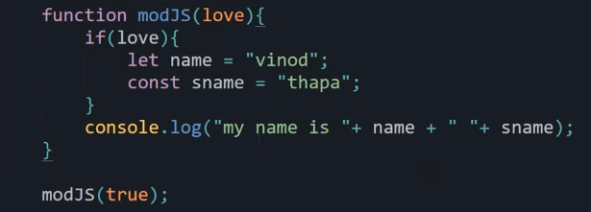 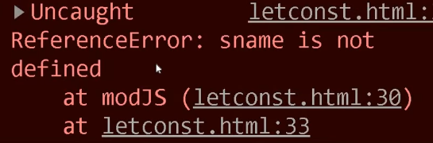

Eikhanay use kora hoyesay let ar const segula holo block scoped ar block scoped er bairay esay print kora hoyesay tai eikhanay error dekhabay. Block scoped er baray console kora jabay na.

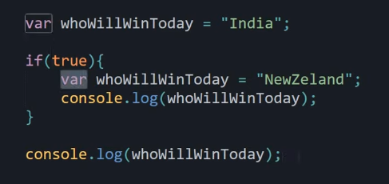 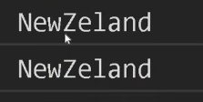

Atfirst if er vitoray console korbay ebong print korbay newzeland ebong ei value ta var er store koray rakhbay so block scoped er bairay jokhon print kora hobay tokhon oi ager store kora value tai dekhabay.

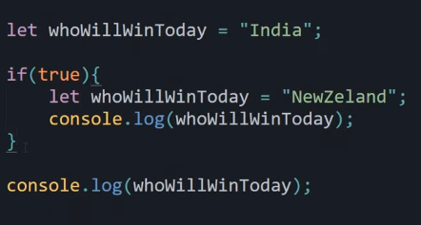 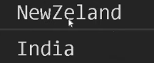

Block scoped er vitoray let er moddew value assaign kora assay so prothome newzland dekhabay then block scoped er bairay aber console kora hoyesay so tokhon bairer let er value ta dekhabay.

Uporer eikhany const use korlay ekoi value dekhabay karon ekta block scoped er moddew console kora hoyesay abar block scoped er bairay aber console kora hoyesay so dui const er moddee kono somporko nai.